Production Model Design Report

S2019

|  |  |  |  |
| --- | --- | --- | --- |
| Lab Section: | 2 | Group: | 1 |

# Team Members

|  |  |  |
| --- | --- | --- |
| # | Name | Role |
| 1 | Malek Karray | Embedded Hardware/Software Developer |
| 2 | Farid-Anthony Berbari | Embedded Hardware/Software Developer |

[Below is an example of a fictional project. Replace the text with your own.]

# Design Overview

## Problem Statement

Traditional wheelchairs put too much physical strain on the user and are very tedious to use. With rapid advancements in technology, wheelchairs fall well behind in the era of autonomy. As a result, existing solutions require constant attention from the user. Lack of modernized technologies also leaves traditional wheelchairs prone to collisions.

## Design Scope

Our wheelchair solves the problem of being prone to collisions by autonomously detecting obstacles and avoiding collision with them. The wheelchair also solves the problem of requiring continued user attention by providing an interface to the user where they can specify a destination and drive there without any more user input.

## We assume that the user is capable enough with their hands to be able to use a keypad, that the user can speak loudly enough to operate the voice activation, and that the environment the user is in is not so loud that the voice activation would constantly be tripped.

## Project Design Requirements

1. Requires less physical strain than a traditional wheelchair

2. Displays important information such as RPM, direction, and distance to destination

3. Voice activated start and stop of the wheelchair

4. Autonomously takes user to location of choice

5. Wheelchair has collision prevention and avoidance functionality

## System-Level Design (High-Level)

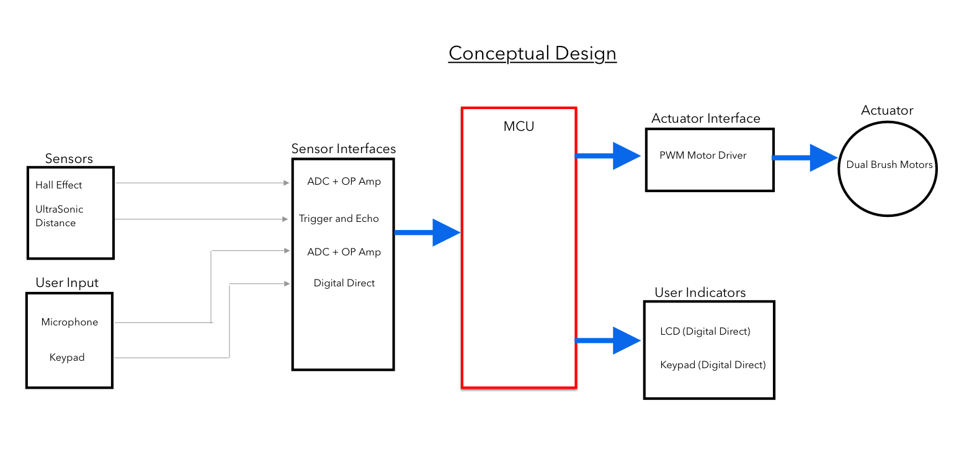

Figure 1. Conceptual design: High level block diagram of entire system



Figure 2. Hardware Feasibility Model: Describes the I/O for all hardware components in our prototype

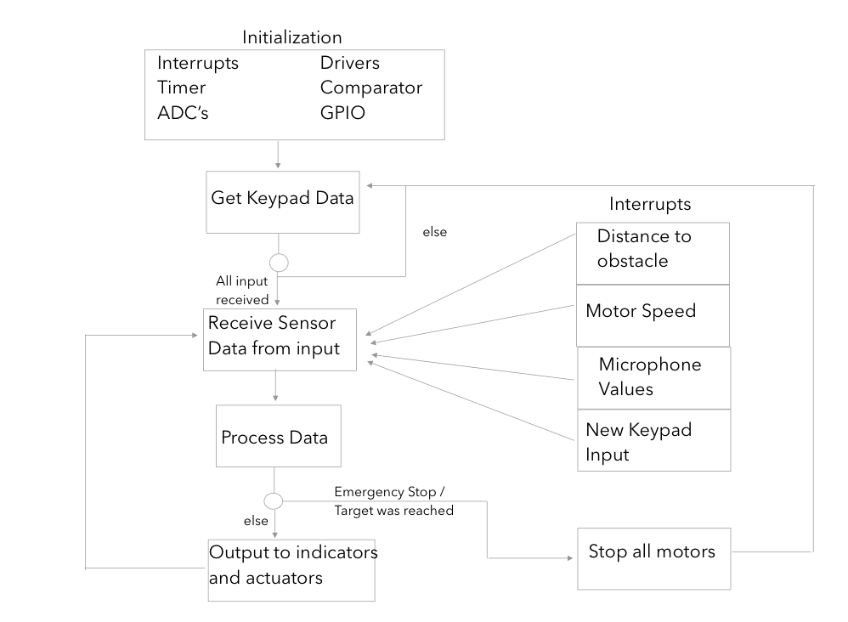

Figure 3. Software Feasibility Model: Describes our overall interrupt driven software architecture.

## Completed Prototype

[Include one or more pictures of your completed prototype system and add appropriate figure captions to explain what each picture shows.]



Figure 4. Completed PCB



Figure 6. Top view of final prototype



Figure 7. From left to right, the LCD demonstrates average RPM and distance to location in meters

## Preliminary Production Design Changes

As of right now, our prototype successfully has collision prevention. An ideal next step would be to also implement collision avoidance; Instead of completely stopping the system and requiring more user input when near an object, calculating a new path would be more reasonable functionality.

An addition that would really enhance the functionality of our wheelchair is GPS. With this capability, the wheelchair would be able to navigate to places that are further away from the start point. It would also allow the user to be less knowledgeable about his surroundings, as he could input addresses rather than absolute distances and direction.

Obviously, a wheelchair must be able to move around. Our current prototype takes power from a wall socket which is unacceptable. On our next iteration, we would need to power the entire system with a battery.

# Member 1 Production Details

[Malek Karray] – ID# [20722149]

## Design for Reliability

Reliability is something that a consumer certainly seeks when purchasing a new product. The notion of quality over quantity is certainly something we abided by throughout this term. Consumers are willing to spend more money on a product in which they have confidence. Designing for Reliability of course is not necessarily always the proper action to take, though for many applications it is of up most importance. Products dealing with human safety, important data, consistency, and real-time systems are all examples where reliability is necessary. As one can imagine, reliability comes in many shapes and forms. The definition I chose to follow is one that states a system should act exactly as the user expects it to for an overwhelming majority of the time. The purpose of reliability is to ensure the user can trust the product and use it without doubting the safety, consistency, and functionality of the system. The question that remains is, how can we design a reliable system in general? Intuitively, the best way to do this is reduce as much unexpected behaviour as possible. This can be accomplished by doing unit tests on individual modules in the system followed by integration tests to ensure everything works well together. In depth testing will certainly weed out a majority of unexpected issues in software, but to have reliable hardware we must plan ahead. Steps to mitigate hardware issues can be clearly reading up on datasheets to know the limits of your system such as power consumption and temperature ranges. Overall, reliability is something that should be instilled in every product in one way or another, but the extent to which we follow through with it greatly depends on the user’s needs.

Now that we’ve established what reliability means, why it’s important, and how to achieve it, we can analyze the relevance of it in a product like ours. The use case for our smart wheelchair is to reduce physical strain on the user, prevent collisions, and display important information to the user about their trip. The people using our wheelchair are likely ones who are physically unable to walk around and heavily rely on the wheelchair’s functionality to get them from A to B in a safe manner. It should be quite clear that reliability is a crucial promise we must keep with our consumers. The safety of the user is of upmost importance in a product like ours, this means our safety mechanisms should be ones that we have explicitly designed for reliability. In particular, our keypad must be able to properly convert the user’s input, our ultrasonic sensor should be consistently gathering data on its surroundings, and our microphone should be able to pick up the user’s voice in case of an emergency stop at any time. On top of that, our hardware should ensure no pins or traces are burned and no component drains the current from another. Knowing these strict reliability requirements, we designed our product with the following preventative measures. We de-bounced our keypad using a software delay to prevent our state machine from reading the same value multiple times as well as making sure one long button press isn’t mistaken as two inputs. Now our user can be sure that our product will always accurately interpret where they intend to move. For our ultrasonic, we calculated that an object 30cm away from the wheelchair would be the optimal distance to avoid a collision while still slowing down the vehicle at a reasonable speed. On every iteration of our state machine, our ultrasonic sensor provides new data by sending a pulse and receiving it on the echo pin with an interrupt in real time. Using two constants, the speed of sound and the frequency of the micro-controller’s clock, we can be confident in the readings we receive regarding our surroundings. To ensure the user’s voice is picked up at any given time during a moving state in our vehicle, we connected the output of our microphone to an ADC pin on the microcontroller and used an ADC driven interrupt. This allowed us to manually control the threshold at which our user’s voice can be heard by the machine. In designing this, we wanted to ensure normal conversation or white noise did not activate a force stop while simultaneously making it easy for the user to stop the vehicle if need be. Through thorough testing, we came out with a threshold that was perfect for the use case of our microphone and can be certain that the user’s voice will be detected when necessary. In regards to our hardware, we placed decoupling capacitors as close as possible to our main sensors and actuators to filter high frequency voltage spikes that could damage the device. On top of this, we also used different net classes to prevent the traces from burning when too much current traveled through them. For our 5V devices, we made sure voltage dividers were placed appropriately if anything acted as an input to our micro-controller. Overall, we took as many precautions as possible when building our product and have successfully fulfilled the user’s needs when it comes to having a reliable product.

Moving to a production-ready product, there are certainly some key quirks to our project that must be noted in order to have a fully functional system. Most notably, the ultrasonic distance sensor runs on a protocol that requires the trigger pulse to remain high for approximately 10 microseconds. To ensure the distance readings are meaningful given the current software we have written, the production model should have the clock running at a frequency of 1MHz. The engineer should also make note that no part of the physical body on the production model covers the ultrasonic sensor so the readings are valid. In terms of a mechanical improvement that can be made, the keypad as is implemented now hovers on air and is prone to having pins broken. A simple fix to this is to have a small groove for the keypad in order to have it lying flat and securely. The keypad is the only way in which the user can input direction and distance to travel so the product becomes useless if that interaction cannot happen. Another notable addition to the product would be to place more magnets along the perimeter of the wheel in order to get more information from our hall effects. Right now, we receive updated data at the end of a full revolution of the wheel. This is fine for providing useful information to the user such as average rpm and distance left to travel, but it was a bit short sighted when trying to orient the direction of our wheelchair. A very realistic situation is one in which a 90-degree turn happens before the magnet even reaches the hall effect. By placing more, we get quicker information on the current speed of the wheels and how much they have actually turned. Finally, the last note I would make to an engineer would be to replace all the adapters and USB’s plugging into our machine with batteries. It makes no sense for a wheelchair to be confined to the length of the wires in a real-world application. This would take careful consideration from the engineers because they would need to ensure the batteries remain at either a stable 5V or 3.3V as those are the voltages which prevent our pins from being fried while still providing enough power to all components across our system.

## Safety Considerations

While safety and reliability go hand in hand, in this section I will go in depth about what it means for a product to be designed with safety considerations, why they are important, and how to apply them to any product in general. Safety Considerations are a crucial piece of any consumer facing product. When properly designed, they ensure every party involved has little to worry about. It is very unethical for product developers to produce something without considering the safety standards that must be met to prevent potential injuries on the user or those around them. Things like hazardous materials, fire hazards, mechanical failures, or physical strain are situations in which engineers must be cautious when providing a product to the public. Depending on the product, different considerations must be made to best ensure a safety fool proof system. Well-designed hardware and software are a given, but this dives back into the world of reliability. In a non-STEM context, safety considerations work on a higher level that relate to the actual features of a product and how they keep the user protected from any potential harm. Safety mechanisms in a car are a perfect example of this point. Features like emergency breaks, seatbelts, and airbags are all safety considerations the product designers made when producing a vehicle, the reliability of those features is a discussion that can be held at a more technical level.

When it comes to our wheelchair project, we designed our product with the safety of our user as a main concern. Many of the features we’ve implemented are solely for the purpose of collision prevention and keeping our user as far from danger as possible. A smart wheelchair is a perfect example of a product in which the user relies heavily on the safety considerations we put in place. It is fair to assume that the condition of the people using our product is already not so great, and so extra care must be put in place to take preventative measures wherever we can. The first safety consideration we put into place relates to the rpm we drive our wheels at. We have a particular threshold rpm set in software and if the two wheels aren’t travelling at that speed, then we increase the rpm until they do. This feature is put in place for travelling in tough conditions, such as uphill climbing or sticky surfaces. Simultaneously, this feature also ensures both wheels are spinning at the same speed which provides better symmetry in our motion. Another safety consideration we made was collision prevention. There are two mechanisms on our wheelchair that ensure this. The first is using a distance sensor to detect how far from an object we are. If we ever come too close, the system stops on its own. The second is using a microphone that the user can interact with. Upon inputting their destination, the user must speak to the microphone to confirm the choice they have made. This ensures no mistakes are made and the wheelchair does exactly what the user intended to do. While the wheelchair is actually in motion, the user can once again communicate through the microphone to initiate a force stop of the vehicle. This feature is put in place for situations in which a distance sensor won’t do the trick, an example would be the user approaching a steep hill. Our final safety consideration feature lies in the information displayed to the user through our LCD. In real time, we consistently show the average rpm and distance to location so the user can be sure the wheelchair is doing precisely what he asked it to do. If for any reason there is unexpected behaviour, the user can request a force stop through the microphone. These safety considerations are all things that have been carefully thought out through the different design stages of our product. It makes no sense for a consumer to buy our product if there are no mechanisms in place to safely get them from point A to point B.

When taking this prototype to a production-ready product, there are certainly more safety considerations that must be made by the engineer this gets handed off to. From a purely mechanical standpoint, there is no reason for the user to ever be touching the wheels or components from the PCB. Abstracting this away from the user not only reduces the risk of them breaking something, but also keeps them away from moving parts and electric shock. The production model should make it very difficult for the user to have access to these low-level components they have no use for. A next step would be to also allow the user to have more freedom on how they interface with the wheelchair. This can be done by adding some more functionality to the keypad. An example would be a ‘manual mode’ in which the user holds a keypad button down to move in the direction they choose instead of letting the wheelchair do this autonomously. This would certainly come in handy in tight spaces where it is far safer and more convenient for the user to be in full control of the system. This feature ties nicely with another easy safety consideration that can be made, there should be a button on the keypad that indicates a force stop. This will be useful when the user has a hard time speaking loudly (elderly), or does not want to disrupt the people around them and still has to stop the wheelchair for safety purposes. Another safety feature worth adding would be optimal increase and decrease speed of the vehicle. Obviously, the user’s safety will be in question if they are accelerating too fast at an uncomfortable level and are even at risk of falling off the wheelchair if the deceleration is unreasonable. Finally, we must also consider the fact that our user will likely be on the wheelchair for hours at a time. An ergonomic design is an essential safety feature to put in place to avoid any sort of muscle spasms or cramps. Overall, it should be clear by now that a wheelchair must be carefully designed to support any safety considerations that must be made to allow the user to be in good hands at all times and away from any potential danger.

# Appendix – Detailed Design

*Software*

<https://github.com/mkarray1/SmartWheelchair>

Prototype Tables

Table 1: Necessary Design Changes

|  |  |  |
| --- | --- | --- |
| # | Change | Reason/Notes |
| 1 | We had to add a mux to the design | Keypad took more pins then we realised, and with 3 led’s, there were no more pins left over. |
| 2 | We added a potentiometer to the microphone circuit rather than a “set in stone” voltage divider | We realised the microphone circuit required a very precise voltage divider to operate properly. We did not have the exact values of resistors available to make it and decided that the flexibility of a potentiometer would be better regardless. |
| 3 | We had to use a voltage divider on our ultrasonic distance sensor. | To step it down to a 0-3.3V scale so as to not damage micro pins. |

Table 2: Important Notes

|  |  |
| --- | --- |
| # | Note |
| 1 | Api call was too slow to operate the distance sensor. I assumed this was a clock problem rather than a code problem. In the event of a similar problem, I’ll cut out the overhead surrounding the problem and make sure to properly identify it before jumping to solutions. |
| 2 | Look for existing solutions before inventing your own. There was an existing microphone circuit available from Rigidware. Best to use it rather than build my own from scratch. |
| 3 | When doing testing on our motor driver and driving voltages from our msp, we were having issues only to later realize our ground were not connected between the msp and our motor driver. This is certainly something we will check for in the future. |
| 4 | User manuals give descriptions of modules available in the entire family of chips. The datasheet will provide the info of whether that module is available and what pins it’s connected to. |

Table 3: Hardware Signal Test Plan

|  |  |  |  |  |  |
| --- | --- | --- | --- | --- | --- |
| Signal (TP*) | Property | Required Software Mode | Min | Nominal | Max |
| UltrasonicTrig* | Voltage | Query obstacle presence | 3V |  | 5 V |
|  | Period | Query obstacle presence | 10uS | 11uS | 12uS |
| HallEffectOutput* | Voltage | Gather RPM | 0V |  | 3.3V |
| MicrophoneXOutput* | Voltage | IsEmergencyStopRequested | 1.3V |  | 3 V |
| PWMX* | Voltage | Adjust Motors | 2V |  | 3.3V |
|  | DutyCycle | Adjust Motors | 0% |  | 100% |
|  | Period | Adjust Motors | 50 Hz |  | 1 KHz |
| echoToMicro* | Voltage | Receive Distance | 0V |  | 3V |
|  | Period | Receive Distance | 120uS |  | 24mS |

Table 4: Hardware Signal Connectivity

|  |  |  |  |
| --- | --- | --- | --- |
| Signal | MSP430FR4133 Pin | LaunchPad J1/J2 Pin | Prototype Connection |
| PWMA Out | P1.7 (PWM) | J2 pin 19 | U2 pin 4 (OpAmp V+) |
| PWMB Out | P1.6 (PWM) | J2 pin 18 | Moisture sensor out |
| motorAdir1 | P5.0 | J2 pin 17 | AIN1 |
| motorAdir2 | P5.2 | J2 pin 15 | AIN2 |
| motorBdir1 | P5.3 | J2 pin 14 | BIN1 |
| motorBdir2 | P1.3 | J2 pin 13 | BIN2 |
| ultrasonicTrig | P1.4 | J2 pin 12 | trig |
| echoToMicro | P1.5 | J2 pin 11 | Echo to micro |
| micOpampOut | P8.1 | J1 pin 2 | Mic op amp output |
| muxControllerInput0 | P1.1 | J1 pin 3 | S0 |
| muxControllerInput1 | P1.0 | J1 pin 4 | S1 |
| muxControllerInput2 | P2.7 | J1 pin 5 | S2 |
| hallEffect1Output | P8.0 | J1 pin 6 | Hall effect output 1 |
| hallEffect2Output | P5.1 | J1 pin 7 | Hall effect output 2 |
| keypadCol1Interrupt | P2.5 | J1 pin 8 | Keypad col1 interrupt |
| keypadCol2Interrupt | P8.2 | J1 pin 9 | Keypad col2 interrupt |
| keypadCol3Interrupt | P8.3 | J1 pin 10 | Keypad col3 interrupt |

Table 5: Power Rail Currents

|  |  |
| --- | --- |
| Power Rail | Expected max current |
| 5V | 300mA |
| 3.3V | 45mA |

Block Diagrams



Conceptual design: High level block diagram of entire system



Hardware Feasibility Model: Describes the I/O for all hardware components in our prototype



Software Feasibility Model: Describes our overall interrupt driven software architecture.



Module hierarchy

Schematic



Wheelchair Schematic

Layout



Top layer layout with 3.3V copper-pour



Bottom layer layout with GND copper-pour

Prototype



Completed PCB



Top view of final prototype



From left to right, the LCD demonstrates average RPM and distance to location in meters